**Distributed Computing**

**Chapter 3: Synchronization**

**

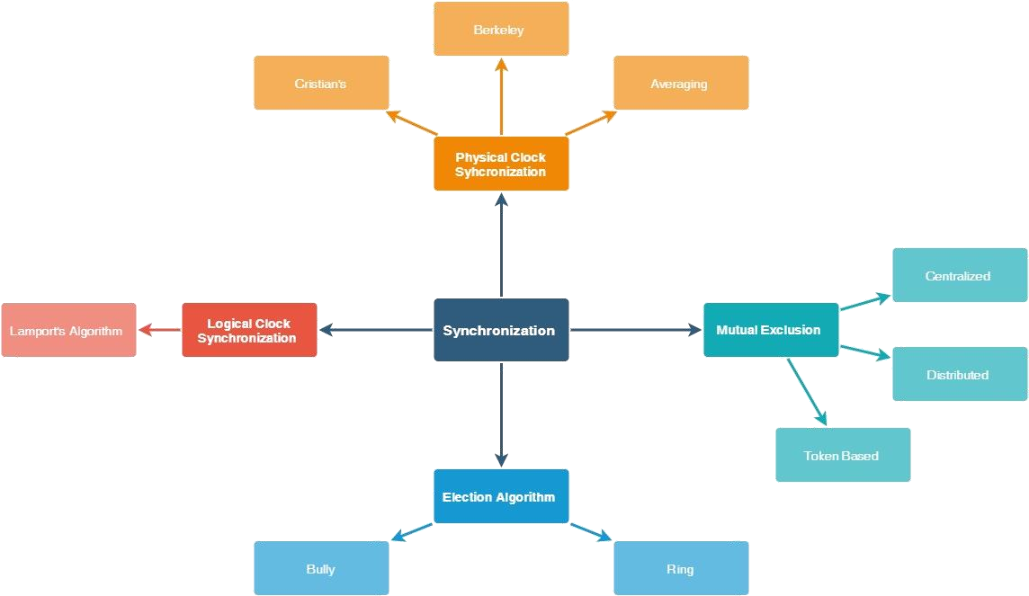

VIDYALANKAR INSTITUTE OF TECHNOLOGY (LMR OF DISTRIBUTED COMPUTING)



## Physical Clock Synchronization



Physical Clock Synchronization

Centralized

Distributed

Cristian

Berkeley

Averaging

Local

Global

VIDYALANKAR INSTITUTE OF TECHNOLOGY (LMR OF DISTRIBUTED COMPUTING)



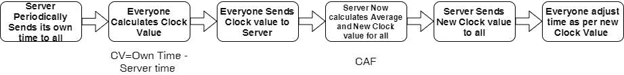

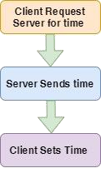**CRISTIAN’S ALGORITHM**

**BERKELEY ALGORITHM**

# Physical Clock Synchronization



VIDYALANKAR INSTITUTE OF TECHNOLOGY (LMR OF DISTRIBUTED COMPUTING)





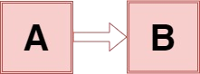

**Happened Before Relationship**

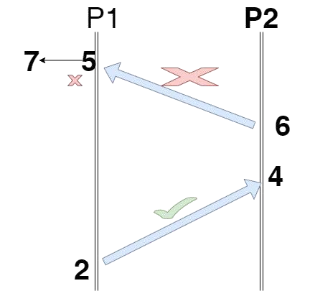**Lamport’s Algorithm**

# Logical Clock Synchronization

VIDYALANKAR INSTITUTE OF TECHNOLOGY (LMR OF DISTRIBUTED COMPUTING)

* 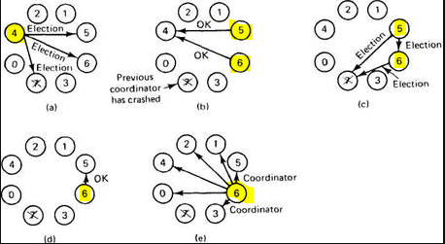Bully

**TYPES OF**

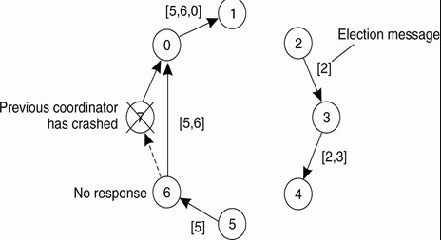**Election algorithm**



* Ring



**Deadlock detection**

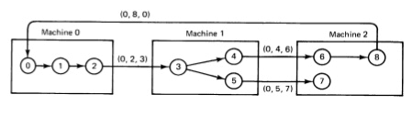

VIDYALANKAR INSTITUTE OF TECHNOLOGY (LMR OF DISTRIBUTED COMPUTING)

Mutual Exclusion Algorithm

## Mutual Exclusion Algorithm

Centralized Distributed

Non

Token Based

Token Based

Ricart Agrawala Algorithm

Lamport’s Algorithm

Maekawa’s Aglorithm

Token Ring Token Bus Raymond

Suzuki Kasami



VIDYALANKAR INSTITUTE OF TECHNOLOGY (LMR OF DISTRIBUTED COMPUTING)

Tree

### Types of Clock Synchronization

* + **Physical**

### Centralized

* + - * **Cristian’s Algorithm**
      * **Berkeley Algorithm**

### Distributed

* + - * **Local Averaging**
      * **Global Averaging**
  + **Logical**

### Happened Before Relationship

* + - **Lamport’s Algorithm**
* **Election Algorithm**
  + **Bully**
  + **Ring**
* **Deadlock Detection**
  + **CHM**

### Types of Mutual Exclusion Algorithm

* + **Centralized**
  + **Distributed**

### Non Token based

* + - * **Ricart Agrawala Algorithm**
      * **Lamport Algorithm**
      * **Maekawa Algorithm**

### Token Based

* + - * **Token Ring**
      * **Token Bus**
      * **Raymond Tree Algorithm**
      * **Suzuki Kasami Algorithm**

**Final Summary**



THANK YOU !!!

Subscribe to my channel ***amit nerurkar*** and hit the bell icon to get more updates